Lab Task 5:
Adversarial Search: Minimax & Alpha-Beta Pruning
Subject: Artificial Intelligence Lab
Name: Ayesha Fayyaz
Roll No: SU92-BSAIM-F25-117
Program: BS Artificial Intelligence, Superior University of Lahore
Submitted to: Sir Rasik
Section: AI-3B

In this lab I used a small game tree with 8 leaf scores [3, 5, 2, 9, 0, 7, 0, 0]. The root is a MAX node, the middle level is MIN and the level above the leaves is MAX. I found the best value first with Minimax and then with Alpha-Beta pruning, and compared how many leaves each one had to look at.
Hand trace of Minimax. Starting from the leaves: max(3,5)=5, max(2,9)=9, max(0,7)=7, max(0,0)=0. Then at the MIN level: min(5,9)=5 and min(7,0)=0. At the root: max(5,0)=5. So the optimal value is 5 and MAX should go to the left side.
Tree no 1: [3,5,2,9,0,7,0,0]
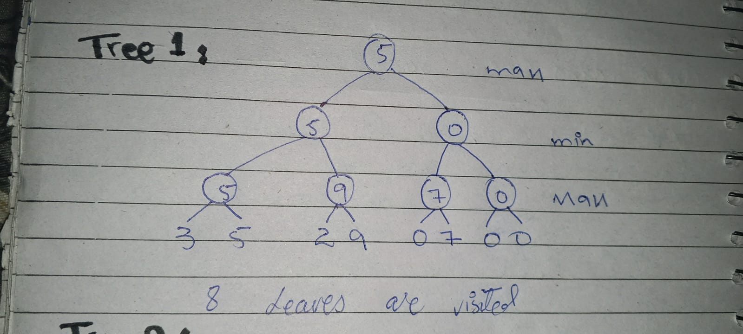
Code. I wrote both algorithms and added a counter that increases every time a leaf is evaluated. The function run prints the value and the leaf count of both algorithms for a given tree. 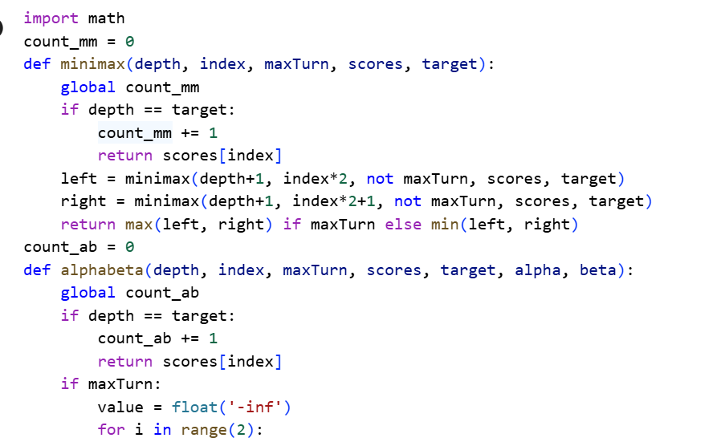 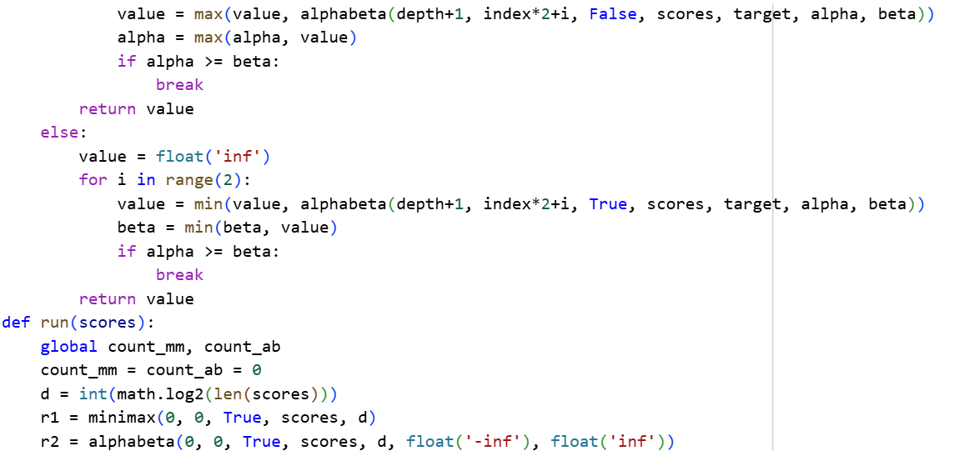 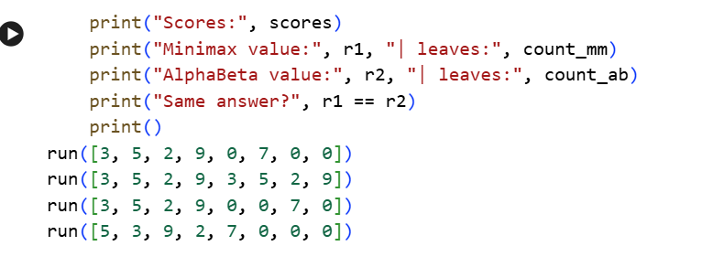
Output. I ran the code on three trees. In all of them Minimax and Alpha-Beta returned the same value, 5. Minimax visited 8 leaves every time, while Alpha-Beta visited 8, 6 and 6 leaves.
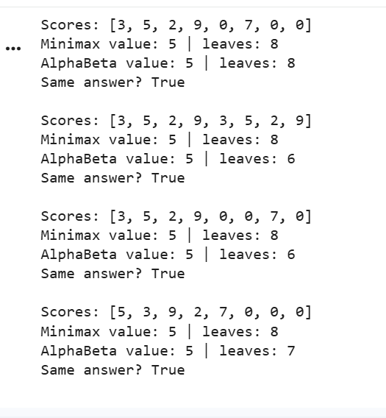
How pruning happened. For the tree [3, 5, 2, 9, 3, 5, 2, 9], alpha becomes 5 after the left side is finished. In the right MIN node the first child gives 5, so beta is also 5. Since alpha >= beta, the second child (leaves 2 and 9) is skipped.
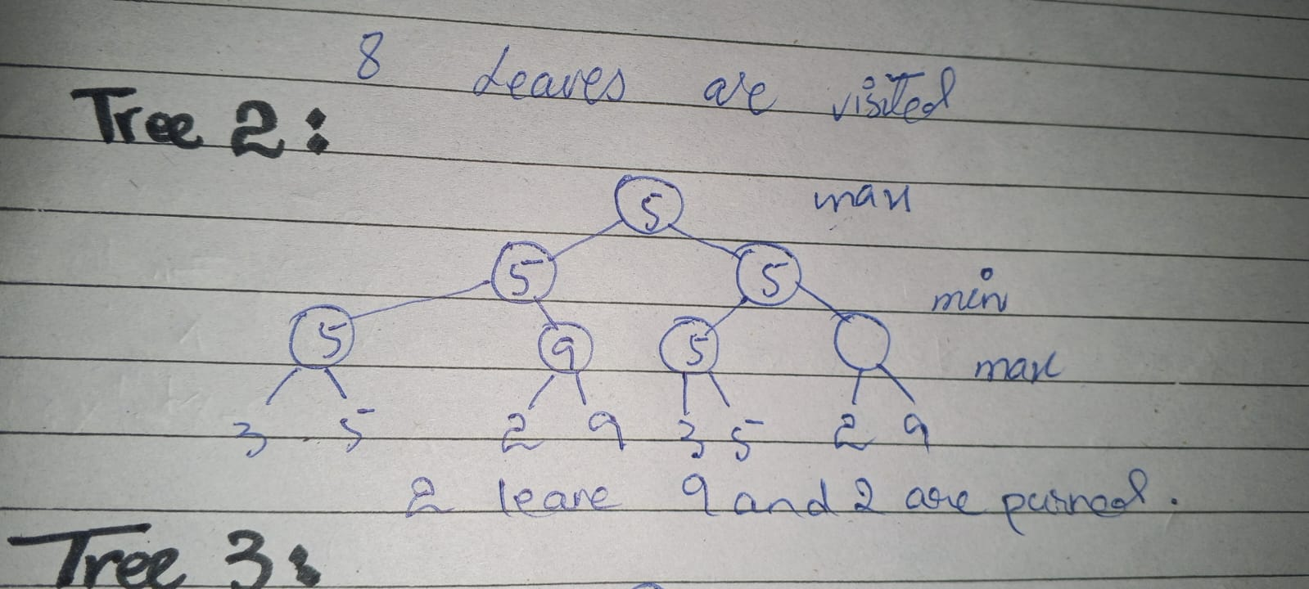
Reordering the leaves. For [3, 5, 2, 9, 0, 0, 7, 0] alpha is 5 at the root and the first child of the right MIN node gives 0, so beta = 0 and alpha >= beta. The leaves 7 and 0 are skipped, so only 6 leaves are checked. The value is still 5.
I also tried [5, 3, 9, 2, 7, 0, 0, 0], where Alpha-Beta visited 7 leaves and the answer was again 5.
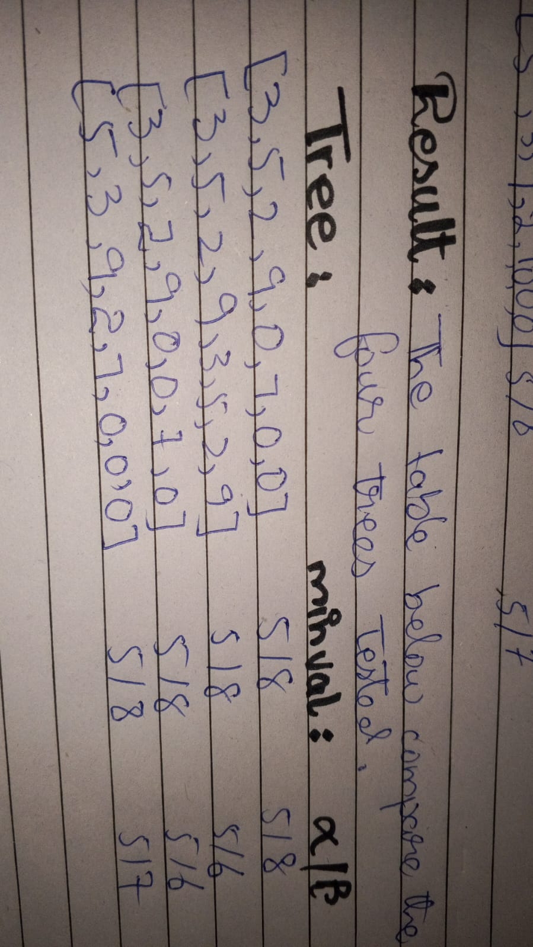

. Alpha-Beta pruning always gave the same answer as Minimax, so pruning does not change the decision. It only reduces the work. In the first tree no pruning happened because the right MIN node first got 7, which is bigger than alpha = 5, so nothing could be cut. This shows that the number of leaves saved depends on the order of the moves, which is why move ordering is important.

